**Bio-Self™ COVID-19 Antigen Home Test** Rapid Diagnostic Test for Detection of SARS-CoV-2 Antigen

**For Emergency Use Authorization (EUA) Only For use with anterior nasal swab specimens For *in vitro* diagnostic use**



COVID-19 Antigen Home Test



***Rapid Diagnostic Test for the Detection of SARS-CoV-2 Antigen***

HEALTHCARE PROVIDER INSTRUCTIONS FOR USE

**Bio-Self™ COVID-19 Antigen Home Test** Rapid Diagnostic Test for Detection of SARS-CoV-2 Antigen

For *in vitro* Diagnostic Use

For use with anterior nasal swab specimens For Emergency Use Authorization (EUA) Only

# INTENDED USE

The Bio-SelfTM COVID-19 Antigen Home Test is a lateral flow immunoassay intended for the qualitative detection of nucleocapsid protein antigen from the SARS-CoV-2 virus.

This test is authorized for non-prescription home use with self-collected anterior nasal (nares) swab samples from individuals aged 14 years or older or adult-collected anterior nasal (nares) swab samples from individuals aged 2 years or older. This test is authorized for individuals with symptoms of COVID-19 within the first 7 days of symptom onset when tested at least twice over three days with at least 48 hours between tests and for individuals without symptoms or other epidemiological reasons to suspect COVID-19 when tested at least three times over five days with at least 48 hours between tests.

The Bio-SelfTM COVID-19 Antigen Home Test does not differentiate between SARS-CoV and SARS-CoV-2.

Results are for the identification of SARS-CoV-2 nucleocapsid protein antigen, which is generally detectable in anterior nasal (nares) swab specimens during the acute phase of infection. Positive results indicate the presence of viral antigens, but clinical correlation with past medical history and other diagnostic information is necessary to determine infection status. Positive results do not rule out bacterial infection or co-infection with other viruses and the agent detected may not be the definitive cause of disease. Individuals who test positive with the Bio-SelfTM COVID-19 Antigen Home Test should self-isolate and seek follow-up care with their physician or healthcare provider as additional testing may be necessary.

All negative results are presumptive and confirmation with a molecular assay, if necessary for patient management, may be performed. Negative results do not rule out SARS-CoV-2 infection and should not be used as the sole basis for treatment or patient management decisions, including infection control measures such as isolating from others and wearing masks. Negative results should be considered in the context of an individual’s recent exposures, history, and the presence of clinical signs and symptoms consistent with COVID-19.

Individuals who test negative and continue to experience COVID-like symptoms of fever, cough and/or shortness of breath may have SARS-CoV-2 infection and should seek follow-up care from their healthcare provider.

Individuals should provide all results obtained with this product to their healthcare provider for public health reporting and to receive appropriate medical care. All healthcare providers will report all test results they receive from individuals who use the authorized product to relevant public health authorities in accordance with local, state, and federal requirements using appropriate LOINC and SNOMED codes, as defined by the Laboratory In Vitro Diagnostics (LVID) Test Code Mapping for SARS-CoV-2 Tests provided by CDC.

The Bio-SelfTM COVID-19 Antigen Home Test is intended for non-prescription self-use and/or, as applicable for an adult lay user testing another person aged 2 years or older in a non-laboratory setting. The Bio-SelfTM COVID-19 Antigen Home Test is only for *in vitro* diagnostic use under the Food and Drug Administration’s Emergency Use Authorization.This product has not been FDA cleared or approved.

# EXPLANATION OF THE TEST

COVID-19 (short for ‘Coronavirus Disease 2019’) is a disease first recognized in 2019 that is caused by a type of novel coronavirus called SARS-CoV-2. Due to its rapid spread, the World Health Organization (WHO) recognized the disease as a global pandemic on March 11, 2020. Individuals infected with SARS-CoV-2 may have a range of symptoms from asymptomatic infection to severe respiratory illness and even death. The virus is spread primarily from person to person through respiratory particles, even by individuals without symptoms. The Bio-Self™ COVID-19 Antigen Home Test is a rapid, qualitative immunochromatographic immunoassay for the determination of the presence of antigens from SARS-CoV-2 in direct anterior nasal swab specimens. The Bio-Self™ COVID-19 Antigen Home Test Kit is comprised of a Test Cassette, Sample Tube, Tube Cap, Anterior Nasal Swab (sample collection device), and Waste Bag. The Test Cassette is composed of several materials which, in combination, can detect SARS-CoV-2 antigens.

The sample should be collected with the provided nasal swab only. The swab containing the sample is then added directly into the Sample Tube containing the sample extraction solution and mixed. The sample extraction solution is then added into the sample well of the test cassette. The sample mixture is absorbed through the sample pad on the Test Strip to initiate the test run via capillary action. This sample mixture continues to migrate up the Test Strip by capillary action, until it rehydrates the pink/purple colored conjugate.

The sample mixture liquid will continue to move up the Test Strip across the nitrocellulose membrane containing two reagent lines, contacting the Test Line first and then the Control Line. If SARS-CoV-2 antigen is present in the sample, it will bind to the anti-SARS-CoV-2 conjugate particles and then be captured on the Test Line, forming a pink/purple line indicating a SARS-CoV- 2 antigen positive test result. The sample mixture liquid will continue to move up the Test Strip and will bind to the Control Line, forming a pink/purple line, to indicate the test was run correctly and establish assay validity. The Control Line will appear on all valid tests whether the Test Line gives a reactive or non-reactive result. If a pink/purple colored Control Line does not appear, the test is invalid, and the specimen must be retested. The liquid will continue to be drawn up to the absorbent pad of the Test Strip until the color on the membrane has cleared within 15 to 30 minutes after the start of the test.

The results of the test are interpreted between 15 to 30 minutes. Refer to the Interpretation of Results section.

# MATERIALS AND REAGENTS PROVIDED

The Bio-Self™ COVID-19 Antigen Home Test is offered in a 1, 2, 5, and 20 test(s)/kit size. The kit configurations are provided below:

|  |  |  |  |  |  |
| --- | --- | --- | --- | --- | --- |
|  | **Number of Test(s)/Kit** | **1 Test/Kit** | **2 Tests/Kit** | **5 Tests/Kit** | **20 Tests/Kit** |
| **Reagent/ Material** | Bio-Self™ COVID-19 Test Cassette | 1 | 2 | 5 | 20 |
| Sample Tube | 1 | 2 | 5 | 20 |
| Tube Cap | 1 | 2 | 5 | 20 |
| Anterior Nasal Swab | 1 | 2 | 5 | 20 |
| Waste Bag | 1 | 2 | 5 | 20 |
| Quick Reference Instructions | 1 | 1 | 1 | 1 |

# MATERIALS REQUIRED BUT NOT PROVIDED

Timer

# QUALITY CONTROL

Each Bio-Self™ COVID-19 Antigen Home Test has a built-in internal procedural control. The pink/purple line appearing at the “C” position is an internal procedural control. This procedural Control Line indicates that sufficient flow has occurred, and the functional integrity of the test device has been maintained. A distinct pink/purple Control Line should always appear if the test has been performed correctly. If the Control Line does not appear, the test result is invalid, and a new test should be performed.

# TEST PROCEDURES

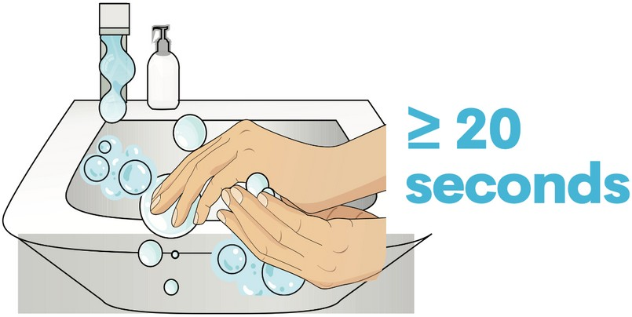Wash your hands thoroughly for at least 20 seconds before the test.

**1**

Unpack components, and place on a flat, clean surface.

**2**

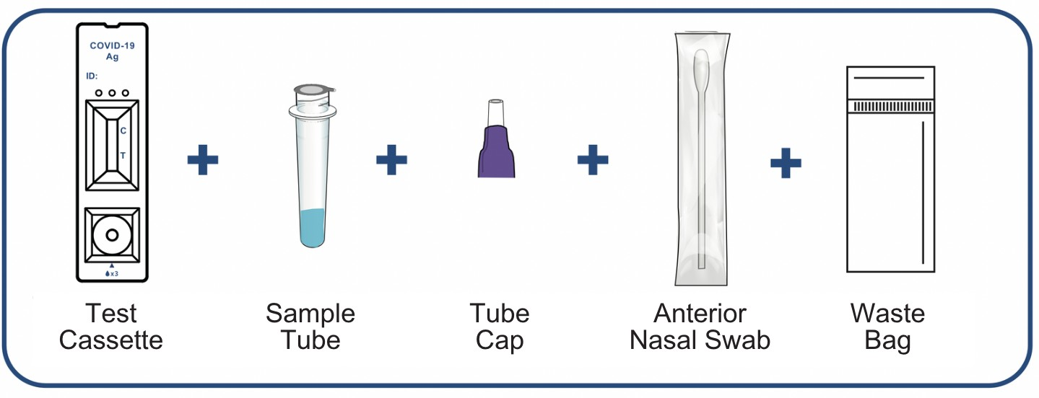

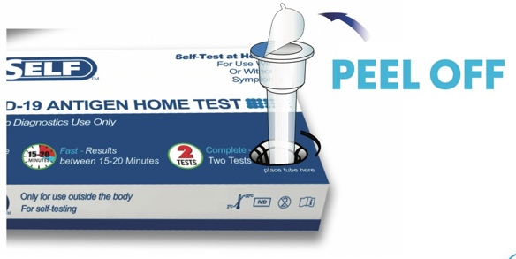

Locate sample tube and place in box holder. Gently peel off the aluminum foil seal.

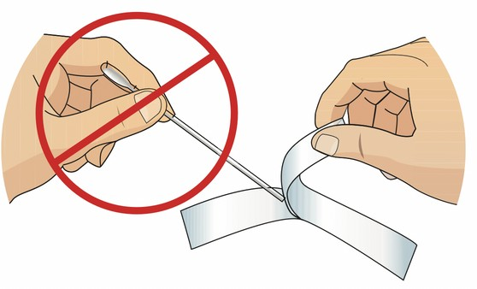**NOTE: Please blow your nose before collection.** Remove the swab from its wrapper, being careful not to touch the fabric tip of the swab with your hands.

**3**

**4**

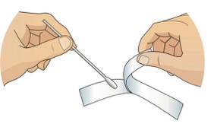

Gently insert the swab no more than 3/4 inch into the left nostril. Slowly rotate the swab at least 5 times in a circular path for a total of 15 seconds. Gently remove the swab from the left nostril and place into the right nostril. Repeat the process of rotating at least 5 times in a circular path for 15 seconds. Remove the swab from the right nostril.

**5**

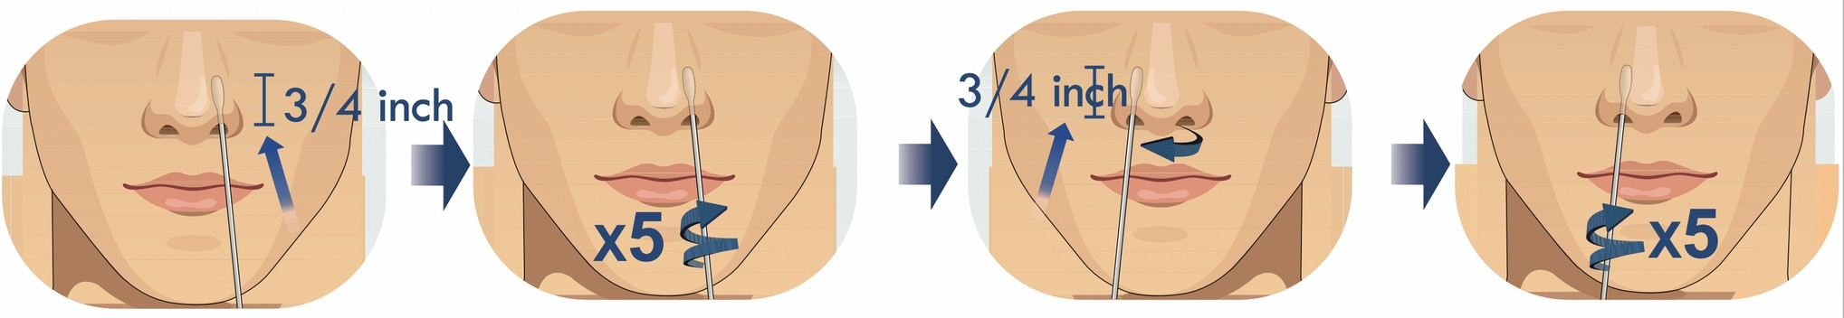

**NOTE: With children, the maximum depth of insertion into the nostril may be less than 3/4 inch.**

Insert the swab into the sample tube. Touch the bottom of the sample tube with the swab tip, and stir at least 5 times. Squeeze the swab in the tube through the outer wall of the tube by finger 5 times.

**6**

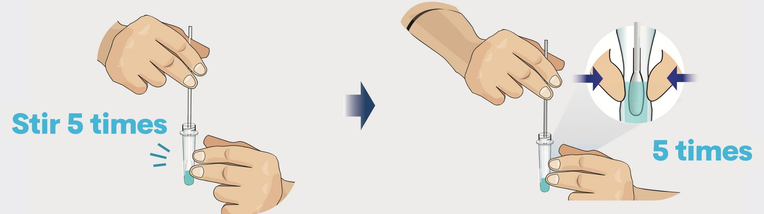

Remove the swab by rotating against the sample tube while squeezing the sides of the tube to release the liquid from the swab. Remove and discard the swab into waste bag provided.

**7**

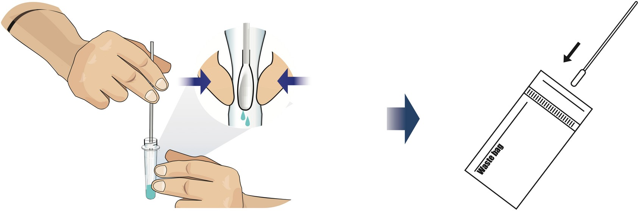

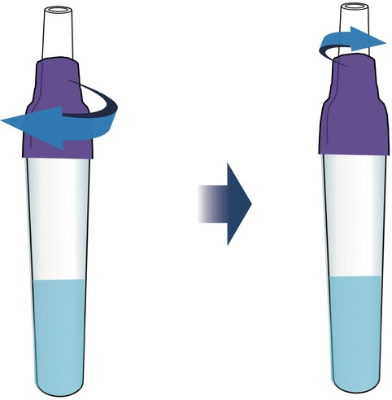Screw the purple tube cap onto the sample tube and then unscrew the top white cap.

**8**

Take out the test cassette. Place it on a flat, dry and clean surface. Turn the sample tube upside down and slowly squeeze 3 drops onto the sample well of the test cassette.

**9**

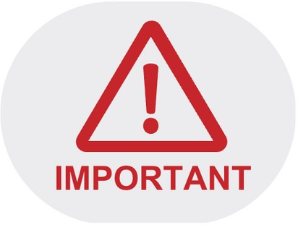

**Please read the results between 15 - 30 minutes after the sample is dropped.**

# INTERPRETATION OF RESULTS

**The test result should be read and interpreted between 15-30 minutes after the sample has been added to the test cassette. The reading and interpretation of the results should not exceed 30 minutes, as this may yield inaccurate results. There is a higher chance of false negative results with antigen test than with laboratory-based molecular tests due to the sensitivity of the test technology. Therefore, repeat (serial) testing for negative results should be performed as indicated below.**

|  |  |
| --- | --- |
| **COVID-19 Detected (Positive)**:  One pink/purple colored line next to "C" and one pink/purple colored line next to "T" indicates a COVID-19 positive result. Any faint visible pink/purple Test (T) Line with the Control Line (C) should be read as positive.  **Repeat testing does not need to be performed if patients have a positive result at any time.**  A positive test result indicates that antigens from COVID-19 were detected, and the patient is very likely to be infected with the virus and presumed to be contagious. Please contact the patient’s doctor/primary care physician (if applicable) and the local health authority immediately and instruct your patient to adhere to the local guidelines regarding self-isolation. There is a very small chance that this test can give a positive result that is incorrect (a false positive). Positive results do not rule out bacterial infection or co-infection with other viruses. The agent detected may not be the definite cause of disease. Individuals who test positive with the Bio-SelfTM COVID-19 Antigen Home Test should self-isolate and seek follow up care with their physician or healthcare provider as additional confirmatory testing with a molecular test for positive results may also be necessary, if there is a low likelihood of COVID- 19, such as in individuals without known exposures to COVID-19 or residing in communities with low prevalence of infection. |  |
| **COVID-19 Not Detected (Negative)**:  If the Control (C) Line is visible, but the Test (T) Line is not visible, the test is negative.  **To increase the chance that the negative result for COVID-19 is accurate, you should:**  **• Test again in 48 hours if the individual has symptoms on the first day of testing.**  **• Test 2 more times at least 48 hours apart if the individual does not have symptoms on the first day of testing.**  A negative test result indicates that the virus that causes COVID-19 was not detected in the sample. A negative result does not rule out COVID-19. There is a higher chance of false negative results with antigen tests compared to laboratory-based tests such as PCR tests. If the test is negative but COVID-19-like symptoms, e.g., fever, cough, and/or shortness of breath continue, follow up testing for SARS-CoV-2 with a molecular test or testing for other respiratory disease should be considered. If applicable, seek follow up care with the primary health care provider.  All negative results should be treated as presumptive and confirmation with a molecular assay may be necessary if there is a high likelihood of SARS-CoV-2 infection, such as in an individual with a close contact with COVID-19 or with suspected exposure to COVID-19 or in communities with high prevalence of infection. Negative results do not rule out SARS-CoV-2 infection and should not be used as the sole basis for treatment or patient management decisions, including infection control decisions. |  |
| **Invalid**:  If the Control (C) Line is not visible, the test is invalid. Re-test with a new swab and new test device. |  |

### Serial Testing Results Interpretation

Repeat testing is needed to improve test accuracy. Please follow the table below when interpreting test results.

|  |  |  |  |  |
| --- | --- | --- | --- | --- |
| **Status on First Day of Testing** | **First Result Day 1** | **Second Result Day 3** | **Third Result Day 5** | **Interpretation** |
| With Symptoms | Positive | N/A | N/A | Positive for COVID-19 |
| Negative | Positive | N/A | Positive for COVID-19 |
| Negative | Negative | N/A | Negative for COVID-19 |
| Without Symptoms | Positive | N/A | N/A | Positive for COVID-19 |
| Negative | Positive | N/A | Positive for COVID-19 |
| Negative | Negative | Positive | Positive for COVID-19 |
| Negative | Negative | Negative | Negative for COVID-19 |

Results should be considered in the context of an individual’s recent exposures, history, and the presence of clinical signs and symptoms.

# STORAGE AND STABILITY

Store the Bio-Self™ COVID-19 Antigen Home Test between 2-30°C (35.6-86°F). Ensure that all kit components are at room temperature before use. Kit components are stable until the expiration date printed on the outer packaging. Do not use beyond the expiration date. The Test Cassette must remain in the sealed foil pouch until use. For the most current expiration dates of this test, please refer to: <https://www.fda.gov/covid-tests>.

# WARNINGS, PRECAUTIONS AND SAFETY INFORMATION

* + Read all instructions carefully before performing the test. Failure to follow the instructions may result in inaccurate test results.
  + In the USA, this product has not been FDA cleared or approved but has been authorized by FDA under an Emergency Use Authorization. This product has been authorized only for the detection of proteins from SARS-CoV-2, not for any other viruses or pathogens. The emergency use of this product is only authorized for the duration of the declaration that circumstances exist justifying the authorization of emergency use of in vitro diagnostics for detection and/or diagnosis of COVID-19 under Section 564(b)(1) of the Federal Food, Drug, and Cosmetic Act, 21 U.S.C. § 360bbb-3(b)(1), unless the declaration is terminated, or authorization is revoked sooner.
  + **Serial testing should be performed in individuals with negative results at least twice over three days (with 48 hours between tests) for symptomatic individuals and three times over five days (with at least 48 hours between tests) for asymptomatic individuals. You may need to purchase additional tests to perform this serial (repeat) testing. If you have had symptoms longer than 7 days, you should consider testing at least three times over five days with at least 48 hours between tests.**
  + An anterior nasal swab sample can be self-collected by an individual age 14 years and older. Children age 2 to 13 years should be tested by an adult.
  + Ensure that there is sufficient lighting for testing and interpretation.
  + Do not use on anyone under 2 years of age.
  + Wear a safety mask or other face-covering when collecting anterior nares swab specimen from a child or another individual.
  + Wash hands thoroughly for at least 20 seconds before testing and after handling nasal swab samples.
  + Immediately use the test kit after opening.
  + Do not read test results before 15 minutes or after 30 minutes. Results read before 15 minutes or after 30 minutes may lead to a false positive, false negative, or invalid result.
  + Test components are single-use. Do not re-use.
  + Keep the test device on a flat surface during testing.
  + Keep testing kit and kit components away from children and pets before and after use.
  + Excess blood or mucus on the swab specimen may interfere with test performance and may yield a false-positive result.
  + Inadequate or inappropriate sample collection, storage, and transport can result in false results. If specimen storage is necessary, swabs can be placed into the extraction vial for up to three hours. Specimens should not be stored dry.
  + When collecting a nasal swab sample, use only the anterior nasal swab provided in the kit.
  + Keep foreign substances and household cleaning products away from the test during the testing process. Contact with foreign substances and household cleaning products may produce an incorrect test result.
  + Use appropriate precautions in the collection, handling, storage, and disposal of patient samples and used kit contents.
  + Handle all specimens as though they contain infectious agents.
  + Do not operate your test outside of storage conditions.
  + Do not interpret the test result before 15 minutes or after 30 minutes of starting the test.
  + Do not use on anyone who is prone to nosebleeds or has had facial or head injury / surgery in the last 6 months.
  + Do not use if any of the test kit contents or packaging is damaged.
  + Do not touch the tip (specimen collection area) of the swab.
  + Do not use the kit past the expiration date.
  + Do not eat, drink, or smoke in the area where the specimens and kit contents are handled.
  + Do not interchange kit contents from different lots.
  + Eye and skin contact with extraction solution should be avoided.
  + Extraction solution should not be ingested.
  + For more information on EUAs please visit: <https://www.fda.gov/emergency-preparedness-and-response/mcmlegal-regulatory-and-policy-framework/emergency-use-authorization>.
  + For the most up to date information on COVID-19, please visit: http://www.cdc.gov/COVID19.

**Keep testing kit and kit components away from children and pets before and after use. Avoid contact with your skin, eyes, nose, or mouth. Do not ingest any kit components. The reagent solution contains harmful chemicals (see table below). If the solution contacts your skin, eyes, nose, or mouth, flush with large amounts of water. If irritation persists, seek medical advice: https://www.poisonhelp.org or 1-800-222-1222.**

|  |  |  |
| --- | --- | --- |
| **Chemical Name** | **Labelling of Harm for Each Ingredient** | **Concentration** |
| **Triton X-100** | * **May cause skin irritation (H315)** * **May cause serious eye irritation (H319)** | **0.5%** |
| **ProClin 300** | * **May cause an allergic skin reaction (H317)** * **Causes mild skin irritation (H316)** | **0.1%** |

# LIMITATIONS

* There is a higher chance of false negative results with antigen tests than with laboratory-based molecular tests due to the sensitivity of the test technology. This means that there is a higher chance this test will give a false negative result in an individual with COVID-19 as compared to a molecular test, especially in samples with low viral load.
* The performance of this test was established based on the evaluation of a limited number of clinical specimens collected between May 2022 and July 2022. The clinical performance has not been established for all circulating variants but is anticipated to be reflective of the prevalent variants in circulation at the time and location of the clinical evaluation. Performance at the time of testing may vary depending on the variants circulating, including newly emerging strains of SARS- CoV-2 and their prevalence, which change over time.
* All COVID-19 antigen test negative results are presumptive and confirmation with a molecular assay may be necessary.
* If the patient continues to have symptoms of COVID-19, and both the patient’s first and second tests are negative, the patient may not have COVID-19, however additional follow-up may be needed.
* If the test is positive, then proteins from the virus that causes COVID-19 have been found in the sample and you likely have COVID-19.
* These test results are shown as lines of color. Because these lines can be very faint, users with conditions affecting their vision such as far-sightedness, glaucoma, or color blindness – are encouraged to seek assistance to interpret results accurately (e.g., reading glasses, additional light source, or another person).
* Incorrect test results may occur if a specimen is incorrectly collected or handled.
* This test detects both viable (live) and nonviable SARS-CoV-2. Test performance depends on the amount of virus (antigens) in the sample and may or may not correlate with viral culture results performed on the same sample.

# PERFORMANCE CHARACTERISTICS

## Limit of Detection (LoD)

The Limit of Detection (LoD) of the Bio-Self™ COVID-19 Antigen Home Test was performed to determine the lowest concentration of target virus that can be detected in ≥ 95% of repeat measurements. A series of 2-fold dilutions of heat inactivated SARS-CoV-2 in COVID-19 spiked in negative nasal fluid and a negative control of nasal fluid was prepared. 50µL of the spiked sample preparation was pipetted onto the swab that were then processed per the Instructions for Use (IFU). The serial dilution solution of SARS-CoV-2 and the negative control were tested according to the test’s IFU. Testing for each dilution and control was repeated, and each replicate was tested by using a different kit lot. The preliminary LoD was then determined to be the lowest viral concentration (TCID50/mL) tested that was 100% positive by visual observation, 8.75x103 TCID50/mL, which equates to 437.5 TCID50/swab.

LoD verification was performed by diluting the heat inactivated SARS-CoV-2 in COVID-19 negative nasal fluid solution to the concentration determined from the preliminary LoD (8.75x103 TCID50/mL). 50µL of the spiked sample preparations were pipetted onto the swab that was then processed per the Instructions for Use (IFU) and tested 20 times. The results showed that 80% (16/20) of the replicates from the preliminary LoD were observed to be positive by visual observation. Confirmatory LoD testing was then performed on 20 replicates at a dilution factor x2 of the original preliminary LoD (i.e., 1.75x104 TCID50/mL) and results yielded 100% (20/20). Based upon the testing procedure for this study the LoD of 1.75 x 104 TCID50/mL equates to 875 TCID50/swab.

## Cross-Reactivity (Analytical Specificity)

Cross-reactivity (analytical specificity) studies were performed to determine the analytical specificity of the Bio-Self™ COVID-19 Antigen Home Test in the presence of microorganisms reasonably likely to be encountered in upper respiratory clinical specimens. The microorganisms subjected to these studies were diluted in COVID-19 negative nasal fluid. The final concentrations were approximately >106 CFU/mL for bacteria and 105 pfu/mL or TCID50/mL for viruses. The test concentrations are provided in Table 1. Contrived specimens were prepared by pipetting 50 µL of each sample onto the nasal swab included in the Bio-Self™ COVID-19 Antigen Home Test in triplicate and then immediately tested using the Bio-Self™ COVID-19 Antigen Home Test.

The test results show that none of the wet-lab tested microorganisms produced a false positive result; therefore, no tested microorganisms are cross-reactive with the Bio-Self™ COVID-19 Antigen Home Test. A summary of results is displayed in Table 1.

### Table 1. Microorganisms Concentrations Used for Cross-Reactivity Testing

| **Microorganism** | **Tested Concentration** | **Results**  **(n=3 replicates)** |
| --- | --- | --- |
| Human coronavirus (229E) | 3.50 x 105 TCID50/mL | No Cross-Reactivity (3/3) |
| Human coronavirus (OC43) | 1.02 x 105 TCID50/mL | No Cross-Reactivity (3/3) |
| Human coronavirus (NL63) | 1.06 x 105 TCID50/mL | No Cross-Reactivity (3/3) |
| MERS-coronavirus | 1.11 x 105 TCID50/mL | No Cross-Reactivity (3/3) |
| SARS-coronavirus | 1.25 x 107 pfu/mL | No Cross-Reactivity (3/3) |
| Human adenovirus 1 (AD71) | 5.00 x 106 TCID50/mL | No Cross-Reactivity (3/3) |
| Human Metapneumovirus 16 (hMPV-16) Type A1 | 1.26 x 105 TCID50/mL | No Cross-Reactivity (3/3) |
| Human parainfluenza virus 1 | 1.29 x 105 TCID50/mL | No Cross-Reactivity (3/3) |
| Human parainfluenza virus 2 (Greer) | 1.60 x 105 TCID50/mL | No Cross-Reactivity (3/3) |
| Human parainfluenza virus 3 (C 243) | 8.90 x 106 TCID50/mL | No Cross-Reactivity (3/3) |
| Human parainfluenza virus 4b (CH 19503) | 2.80 x 105 TCID50/mL | No Cross-Reactivity (3/3) |
| Influenza A (H1N1; A/California/07/2009 (H1N1) pdm09 | 5.20 x 106 CEID50/mL | No Cross-Reactivity (3/3) |
| Influenza B virus (B/Lee/40) | 1.00 x 105 pfu/mL | No Cross-Reactivity (3/3) |
| Enterovirus Type 71 (2003 Isolate) | 1.78 x 105 TCID50/mL | No Cross-Reactivity (3/3) |
| Respiratory Syncytial Virus Type B (RSV-B) | 4.57 x 106 TCID50/mL | No Cross-Reactivity (3/3) |
| Human rhinovirus 16 (HRV-16) | 2.80 x 107 TCID50/mL | No Cross-Reactivity (3/3) |
| *Haemophilus influenzae* type b (Eagan) | 6.97 x 107 CFU/mL | No Cross-Reactivity (3/3) |
| *Streptococcus pneumoniae* (19F; Z022) | 1.34 x 108 CFU/mL | No Cross-Reactivity (3/3) |
| *Streptococcus pyogenes* (Z018) | 2.39 x 108 CFU/mL | No Cross-Reactivity (3/3) |
| *Candida albicans* (Z006) | 4.76 x 107 CFU/mL | No Cross-Reactivity (3/3) |
| *Bordetella pertussis* (A639) | 1.96 x 109 CFU/mL | No Cross-Reactivity (3/3) |
| *Mycoplasma pneumoniae* (M129) | 2.70 x 107 CCU/mL | No Cross-Reactivity (3/3) |
| *Chlamydophila pneumoniae (*AR-39) | 1.40 x 107 IFU/mL | No Cross-Reactivity (3/3) |
| *Legionella pneumophila* (Philadelphia) | 3.68 x 109 CFU/mL | No Cross-Reactivity (3/3) |
| *Staphylococcus aureus* (MRSA; COL) | 8.35 x 108 CFU/mL | No Cross-Reactivity (3/3) |
| *Staphylococcus epidermidis* (MRSE; RP62A) | 6.07 x 108 CFU/mL | No Cross-Reactivity (3/3) |
| Nasal Cavity Wash; Pooled Human Donors | Undiluted | No Cross-Reactivity (3/3) |

*In silico* cross reactivity prediction of Human coronavirus; HKU1 (hCoV-HKU1) was performed via sequence alignment (protein BLAST) of SARS-CoV-2 nucleocapsid protein and hCoV-HKU1 and conducted using the NCBI Protein-Protein BLAST blastp suite. Based on the protein BLAST sequence alignment, homology is relatively low (45% across 94% of sequence), but cross-reactivity cannot be ruled out.

## Microbial Interference

Microbial interference study was conducted to determine the impact of microbial interference on results generated using the Bio-Self™ COVID-19 Antigen Home Test.

Microorganisms were pooled in groups of 4 – 5 where stock concentrations allowed; otherwise, they were tested individually according to the test protocol. The final concentration of each microorganism in the diluted pool was >2x106 CFU/mL for bacteria and >2x105 pfu/mL or TCID50/mL for viruses. Microorganisms, their grouping in pooled mixtures (if applicable), as well as final test concentrations are listed in Table 2. The final concentration of SARS CoV-2 in these samples was 5.25 X 104 (3x LoD).

Contrived specimens were prepared by pipetting 50 µL of each sample onto the nasal swab included in the Bio-Self™ COVID-19 Antigen Home Test in triplicate and then immediately tested. All test cards were immediately photographed, and results recorded.

The study results showed that none of the microorganisms tested produced false negative results at the concentrations tested; therefore, none of the microorganisms interfere with the Bio-Self™ COVID-19 Antigen Home Test.

### Table 2. Microbial Interference Study: Groupings and Test Concentrations of Microorganisms

| **Microorganisms/Pooled Mixtures** | **Tested Concentration** | **Results**  **(n=3 replicates)** |
| --- | --- | --- |
| **Mix 1** | | |
| *Chlamydophila pneumoniae*; AR-39 | 1.40 x 107 IFU/mL | No Interference (3/3) |
| *Legionella pneumophila* Philadelphia | 3.68 x 109 CFU/mL | No Interference (3/3) |
| *Mycoplasma pneumoniae* M129 | 2.70 x 107 CCU/mL | No Interference (3/3) |
| *Staphylococcus aureus* MRSA; COL | 8.35 x 108 CFU/mL | No Interference (3/3) |
| *Staphylococcus epidermidis* MRSE; RP62A | 6.07 x 108 CFU/mL | No Interference (3/3) |
| **Mix 2** | | |
| *Bordetella pertussis* A639 | 1.96 x 109 CFU/mL | No Interference (3/3) |
| *Candida albicans* Z006 | 4.76 x 107 CFU/mL | No Interference (3/3) |
| *Haemophilus influenzae* type b; Eagan | 6.97 x 107 CFU/mL | No Interference (3/3) |
| *Streptococcus pneumoniae* 19F; Z022 | 1.34 x 108 CFU/mL | No Interference (3/3) |
| *Streptococcus pyogenes* Z018 | 2.39 x 108 CFU/mL | No Interference (3/3) |
| **Mix 3** | | |
| Influenza A virus (H1N1; A/California/07/2009 (H1N1)pdm09 | 5.20 x 106 CEID50/mL | No Interference (3/3) |
| Human adenovirus 1; AD71 | 5.00 x 106 TCID50/mL | No Interference (3/3) |
| Human Metapneumovirus 16 (hMPV-16) Type A1 | 1.26 x 105 TCID50/mL | No Interference (3/3) |
| Respiratory Syncytial Virus Type B (RSV-B) | 4.57 x 106 TCID50/mL | No Interference (3/3) |
| **Mix 4** | | |
| Human parainfluenza virus 1 | 1.29 x 105 TCID50/mL | No Interference (3/3) |
| Human parainfluenza virus 2; Greer | 1.60 x 105 TCID50/mL | No Interference (3/3) |
| Human parainfluenza virus 3; C 243 | 8.90 x 106 TCID50/mL | No Interference (3/3) |
| Human parainfluenza virus 4b; CH 19503 | 2.80 x 105 TCID50/mL | No Interference (3/3) |
| Human rhinovirus 16; HRV-16 | 2.80 x 107 TCID50/mL | No Interference (3/3) |
| **Mix 5** | | |
| Human coronavirus; 229E | 3.50 x 105 TCID50/mL | No Interference (3/3) |
| Human coronavirus, Middle East Respiratory Syndrome Coronavirus (MERS-CoV), EMC/2012 | 1.11 x 105 TCID50/mL | No Interference (3/3) |
| Influenza B virus; B/Lee/40 | 1.00 x 105 pfu/mL | No Interference (3/3) |
| SARS Coronavirus, Gamma-Irradiated and Sucrose-Purified | 1.25 x 107 pfu/mL | No Interference (3/3) |
| **Individually Tested** | | |
| Enterovirus Type 71 (2003 isolate) | 1.78 x 105 TCID50/mL | No Interference (3/3) |
| Human coronavirus; NL63 | 1.06 x 105 TCID50/mL | No Interference (3/3) |
| Human coronavirus; OC43 | 1.02 x 105 TCID50/mL | No Interference (3/3) |

## Endogenous/Exogenous Interfering Substances

An endogenous/exogenous interfering substances study was conducted to determine the impact of various endogenous and exogenous interference substances when performing testing using the Bio-Self™ COVID-19 Antigen Home Test.

To prepare specimens for testing, a working dilution of heat inactivated SARS-CoV-2 culture fluid, USA-WA1/2020 strain, diluted to 6-fold higher than the LoD in certified SARS-CoV-2 negative nasal fluid (1.05 x 105 TCID50/mL) was prepared. A 1:1 mixture of the working dilution of heat inactivated SARS-CoV-2 culture fluid and working dilution of each potential interfering substance was prepared resulting in a final concentration of heat inactivated SARS-CoV-2 culture fluid at 3-fold higher than the LoD (5.25 x 104 TCID50/mL) and final concentrations of each potential interfering substance as indicated in Table 3. Samples with a concentration of 0 TCID50/mL heat inactivated SARS-CoV-2 were also tested in the presence of all potential interfering substances.

### Table 3. Final Concentration of Potential Interference Substances

| **Potential Interfering Substances** | **Final Concentration** | **Results (5.25 x 104 TCID50/mL SARS-CoV-2;**  **n=3 replicates)** | **Results (0 TCID50/mL**  **SARS-CoV-2;**  **n=3 replicates)** |
| --- | --- | --- | --- |
| Single Donor Human Whole Blood | 4% | No Interference (3/3) | No Interference (3/3) |
| Mucin, Bovine Submaxillary Gland | 0.5% | No Interference (3/3) | No Interference (3/3) |
| Chloraseptic Max Strength Sore Throat Lozenges (Benzocaine/Menthol) | 1.5 mg/mL | No Interference (3/3) | No Interference (3/3) |
| NasoGEL Drip Free Gel Spray | 5% v/v | No Interference (3/3) | No Interference (3/3) |
| Amazon Basic Care Nasal Four Nasal Spray, Phenylephrine Hydrochloride 1%, Nasal Decongestant | 15% v/v | No Interference (3/3) | No Interference (3/3) |
| Afrin Original Maximum Strength 12 Hour Nasal Congestion Relief Pump Mist (Oxymetazoline Hydrochloride) | 15% v/v | No Interference (3/3) | No Interference (3/3) |
| NasalCrom Nasal Spray (Cromolyn Sodium) | 15% v/v | No Interference (3/3) | No Interference (3/3) |
| Zicam Cold Remedy No-Drip Nasal Spray with Cooling Menthol & Eucalyptus (Galphimia Glauca, Luffa Operculata, Sabadilla) | 5% v/v | No Interference (3/3) | No Interference (3/3) |
| Zicam Cold Remedy Citrus RapidMelts (Zincum Aceticum, Zincum Gluconicum) | 5% w/v | No Interference (3/3) | No Interference (3/3) |
| Alkalol (Menthol) | 1:10 dilution | No Interference (3/3) | No Interference (3/3) |
| Chloraseptic Max Strength Sore Throat Spray (Phenol) | 15% v/v | No Interference (3/3) | No Interference (3/3) |
| Tobramycin, Pharmaceutical Secondary Standard; Certified Reference Material | 4 μg/mL | No Interference (3/3) | No Interference (3/3) |
| Mupirocin, Pharmaceutical Secondary Standard | 10 mg/mL | No Interference (3/3) | No Interference (3/3) |
| Flonase Allergy Relief Nasal Spray (Fluticasone Propionate) | 5% v/v | No Interference (3/3) | No Interference (3/3) |
| Oseltamivir Phosphate, Pharmaceutical Secondary Standard; Certified Reference Material | 5 mg/mL | No Interference (3/3) | No Interference (3/3) |

Fifty microliters (50µL) of each diluted sample were transferred to the nasal swab included in the Bio-Self™ COVID-19 Antigen Home Test using a single channel pipette and then immediately tested using the Bio-Self™ COVID-19 Antigen Home Test. All test cards were immediately photographed, and results recorded.

The results showed 100% positive in the presence of all potential interference substances tested; no false negative results were observed. Samples with a concentration of 0 TCID50/mL heat inactivated SARS-CoV-2 were 100% negative in the presence of all potential interference substances tested; no false positive results were observed.

However, observed Test Lines (T) for all samples tested in the presence of whole blood were observed to be more diffuse/weaker than in the presence of other interference substances which may affect interpretation of results closer to the LoD.

## High Dose Hook Effect

High-dose hook effect study was conducted to determine if testing highly concentrated specimens using the Bio-Self™ COVID-19 Antigen Home Test generates false negative results.

A 150µL aliquot of stock heat inactivated SARS-CoV-2 culture fluid (1.51x106 TCID50/mL; Zeptometrix, Cat# 0810587CFHI) was retained for direct testing. A series dilution was prepared by mixing this solution with COVID-19 negative nasal fluid. Two hundred microliters (200µL) of COVID-19 Negative Nasal Fluid was aliquoted as a Negative Control.

Contrived specimens were prepared by pipetting 50 µL of each sample onto the nasal swab in triplicate and then immediately tested using the Bio-Self™ COVID-19 Antigen Home Test. All test cards were immediately photographed, and results recorded.

All sample concentrations tested positive, as expected. Although result interpretation was not negatively impacted at concentrations tested, the highest concentration available for testing was 1.51x106 TCID50/mL of heat inactivated SARS-CoV-2, a concentration that can be exceeded in clinical samples. Therefore, it should be noted that occurrence of a high dose hook effect at very high concentrations of virus cannot be excluded.

## Flex Studies

The robust use of the Bio-Self™ COVID-19 Antigen Home Test was demonstrated by eight (8) Flex studies: Temperature/Humidity variability, Sample elution variability, Sample volume variability, Buffer volume variability, Read time variability, Disturbance during analysis, Device Orientation and Light source variability.

# CLINICAL PERFORMANCE

A prospective study was completed at three (3) sites in the United States for clinical validation of the Bio-Self™ COVID-19 Antigen Home Test for the detection of the SARS-CoV-2 in subject-collected anterior nasal swab samples. The study evaluated the Bio-Self™ COVID-19 Antigen Home Test performance in 253 subjects with symptoms associated with COVID-19. As shown in Table 4, there was diversity in age, sex, race, and ethnicity among those subjects tested. Each enrolled subject either self-collected a sample from their anterior nasal passage (both nostrils), or had the sample collected from him/her by another individual. Each subject then had an anterior nasal sample (both nostrils) collected from him/her by a member of the study personnel for comparator testing.

### Table 4. Demographics and Baseline Characteristics

|  |  |
| --- | --- |
| **Characteristics** | **n (%) of Subjects N=253** |
| **Age**  < 14 years  14 – 24 years  25 – 64 years  ≥65 years | 27 (10.7)  24 (9.5)  108 (42.7)  94 (37.2) |
| **Sex**  Male Female | 105 (41.5)  148 (58.5) |
| **Race**  Asian  Black/African American White  Multiracial | 6 (2.4)  22 (8.7)  222 (88.1)  3 (1.2) |
| **Ethnicity**  Hispanic or Latino Not Hispanic or Latino | 132 (52.2)  121 (47.8) |

Test results from the Bio-Self™ COVID-19 Antigen Home Test (candidate test) were compared to a highly sensitive molecular FDA EUA authorized SARS-CoV-2 assay to determine test performance. As shown in Table 5, the positive percent agreement (PPA) was 96.2% with the 95% confidence interval (CI) of 87.2% to 99.0%. The negative percent agreement (NPA) was 100% with the 95% CI of 96.4% to 100.0%.

### Table 5. Bio-Self™ COVID-19 Antigen Home Test (candidate) Results vs. Comparator Results for Symptomatic Subjects

|  |  |  |  |
| --- | --- | --- | --- |
|  | **Comparator Positives** | **Comparator Negatives** | **Total** |
| **Candidate Positives** | 51 | 0 | 51 |
| **Candidate Negatives** | 2 | 102 | 104 |
| **Total** | 53 | 102 | 155 |
| PPA = 96.2% (95% CI = 87.2% to 99.0%)  NPA = 100% (95% CI = 96.4% to 100.0%) | | | |

### Table 6. Clinical Performance in Symptomatic Subjects Across Days Post Symptom Onset

|  |  |  |  |
| --- | --- | --- | --- |
| **DPSO** | **PPA** | **NPA** | **Total** |
| 0 | 100 % (1/1) | 100% (1/1) | 2 |
| 1 | 100 % (5/5) | 100% (7/7) | 12 |
| 2 | 100 % (11/11) | 100% (19/19) | 30 |
| 3 | 91.7% (11/12) | 100% (24/24) | 36 |
| 4 | 88.9% (8/9) | 100% (20/20) | 29 |
| 5 | 100% (7/7) | 100 % (12/12) | 19 |
| 6 | 100% (7/7) | 100% (15/15) | 22 |
| 7 | 100% (1/1) | 100% (4/4) | 5 |

## Serial Testing Performance

A prospective clinical study was conducted between January 2021 and May 2022 as a component of the Rapid Acceleration of Diagnostics (RADx) initiative from the National Institutes of Health (NIH). A total of 7,361 individuals were enrolled via a decentralized clinical study design, with a broad geographical representation of the United States. Per inclusion criteria, all individuals were asymptomatic upon enrollment in the study and at least 14 days prior to it and did not have a SARS-CoV-2 infection in the three months prior to enrollment. Participants were assigned to one of three EUA authorized SARS- CoV-2 OTC rapid antigen tests to conduct serial testing (every 48 hours) for 15 days. If an antigen test was positive, the serial-antigen testing result is considered positive.

At each rapid antigen testing time point, study subjects also collected a nasal swab for comparator testing using a home collection kit (using a 15-minute normalization window between swabs). SARS-CoV-2 infection status was determined by a composite comparator method on the day of the first antigen test, using at least two highly sensitive EUA RT-PCRs. If results of the first two molecular tests were discordant a third highly sensitive EUA RT-PCR test was performed, and the final test result was based upon the majority rule.

Study participants reported symptom status throughout the study using the MyDataHelps app. Two-day serial antigen testing is defined as performing two antigen tests 36 - 48 hours apart. Three-day serial antigen testing is defined as performing three antigen tests over five days with at least 48 hours between each test.

Out of the 7,361 participants enrolled in the study, 5,609 were eligible for analysis. Among eligible participants, 154 tested positive for SARS-CoV-2 infection based on RT- PCR, of which 97 (62%) were asymptomatic on the first day of their infection, whereas 57 (39%) reported symptoms on the first day of infection. Pre-symptomatic subjects were included in the positive percent agreement (PPA) of asymptomatic individuals, if they were asymptomatic on the first day of antigen testing, regardless of whether they developed symptoms at any time after the first day of testing.

Performance of the antigen test with serial testing in individuals is described in Table 7.

### Table 7. Data Establishing PPA of COVID-19 Antigen Serial Testing Compared to the Molecular Comparator Single Day Testing Throughout the Course of Infection With Serial Testing. Data is From All Antigen Tests in Study Combined.

|  |  |  |  |  |  |  |
| --- | --- | --- | --- | --- | --- | --- |
| DAYS AFTER FIRST RT-PCR POSITIVE TEST RESULT | ASYMPTOMATIC ON FIRST DAY OF TESTING | | | SYMPTOMATIC ON FIRST DAY OF TESTING | | |
| Ag Positive / RT-PCR Positive (Antigen Test Performance % PPA) | | | | | |
| 1 Test | 2 Tests | 3 Tests | 1 Test | 2 Tests | 3 Tests |
| 0 | 9/97 9.3% | 35/89 39.3% | 44/78 56.4% | 34/57 59.6% | 47/51 92.2% | 44/47 93.6% |
| 2 | 17/34 50% | 23/34 67.6% | 25/32 78.1% | 58/62 93.5% | 59/60 98.3% | 43/43 100% |
| 4 | 16/21 76.2% | 15/20 75.0% | 13/15 86.7% | 55/58 94.8% | 53/54 98.1% | 39/40 97.5% |
| 6 | 20/28 71.4% | 21/27 77.8% | 16/18 88.9% | 27/34 79.4% | 26/33 78.8% | 22/27 81.5% |
| 8 | 13/23 56.5% | 13/22 59.1% | 4/11 36.4% | 12/17 70.6% | 12/17 70.6% | 7/11 63.6% |
| 10 | 5/9 55.6% | 5/8 62.5% |  | 4/9 44.4% | 3/7 42.9% |  |

1 Test = one (1) test performed on the noted days after first RT-PCR positive test result. Day 0 is the first day of documented infection with SARS-CoV-2.

2 Tests = two (2) tests performed an average of 48 hours apart. The first test performed on the indicated day and the second test performed 48 hours later.

3 Tests = three (3) tests performed an average of 48 hours apart. The first test performed on the indicated day, the second test performed 48 hours later, and a final test performed 48 hours after the second test.

# TECHNICAL SUPPORT

For questions, or to report a problem, please call 1-800-240-3944.

# SYMBOLS AND ABBREVIATIONS

The following symbols appear in the Bio-Self™ COVID-19 Antigen Home Test product labeling:

|  |  |
| --- | --- |
| Date of manufacture | Date of manufacture  Indicates the date when the medical device was manufactured. |
| Do not reuse | Do not re-use  Indicates a medical device that is intended for one use or uses on a single patient during a single procedure. |
| In vitro diagnostic medical device | In vitro diagnostic medical device  Indicates a medical device that is intended to be used as an in vitro diagnostic medical device. |
| Caution: Read all warnings and precautions in instructions for use | Caution  Indicates the need for the user to consult the instructions for use for important cautionary information such as warnings and precautions that cannot, for a variety of reasons, be presented on the medical device itself. |
| Storage temperature range | Temperature limit  Indicates the temperature limits to which the medical device can be safely exposed. |
| Use by | Use-by date  Indicates the date after which the medical device is not to be used. |
| Batch code | Batch code  Indicates the manufacturer's batch code so that the batch or lot can be identified. |
| Consult instructions for use | Consult instructions for use  Indicates the need for the user to consult the instructions for use. |
| Do not use if package is damaged | Do not use if package is damaged  Indicates a medical device that should not be used if the package has been damaged or opened. |
| Catalogue or model number | Catalog number  Indicates the manufacturer's catalog number so that the medical device can be identified. |